# Homework 6: User Management

Daniel Hutchins – **CIS 483-75**

# Task 4. Assigning User Mappings to Fixed Database Roles

## A. Assigning a user to a database role

## B. Verifying the results

5) Does it fail? Show the result in a screenshot. Describe your observation and explain why it fails.

The query failed because we assigned TestUser-A to the db_denydatawriter role, preventing them from writing data into HumanResources.Department.

10) Does it fail? Show the result in a screenshot. Describe your observation and explain why it fails.

The query failed because we assigned Test-UserB to the db_denydatawriter role in AdventureWorks2016, preventing them from pulling or rather, reading data from HumanResources.Department.

# Task 5. Creating a Custom Database Role

## A. Creating a custom database role

## B. Verifying results

4) Does it work? Show the result in a screenshot. Describe your observation and explain why it works.

The query worked for TestUser-C as we gave them the exclusive SelectOnly role by grant permissions, meaning the user can only Select data.

5) Does it fail? Show the result in a screenshot. Describe your observation and explain why it fails.

The query failed for TestUser-C, as described previously, they only have the SelectOnly role for AdventureWorks2016. This means that they cannot write, and can only select data.

# Task 6. Creating an Application Role

## A. Creating an Application Role

## B. Verifying Results

2) Does it fail? Show the result in a screenshot. Describe your observation and explain why it fails.

The query fails as the application role has not been activated for the application, meaning TestUser-B cannot select data from HumanResources.Employees.

4) Does it work? Show the result in a screenshot. You have to click on Results to view the results. Describe your observation and explain why it works.

The query worked now after the application role was activated, the user in question (TestUser-B) was logged in and is given the application role to read the data from HumanResources.Employee.

# Task 7. Assigning Permissions

9) Does it work? Show the result in a screenshot. Describe your observation and explain why it works.

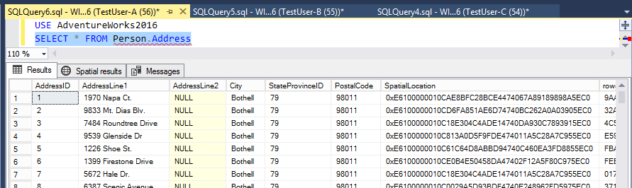

The query works as we gave TestUser-A the permission to select (read) data from the specific table.

13) Run the previous query. Show the result in a screenshot. Describe your observation and explain why it fails.

The query fails as we took away the select permission for TestUser-A in the Securables for them, denying them access from manipulating any data/viewing data from Person.Address.

15) Run the previous query. Show the result in a screenshot. Describe your observation and explain why it works.

The query worked as the db_datareader role overrules Person.Address select in terms of role hierarchy, making it possible for TestUser-A to view the data despite not having specific select roles in Person.Address.

19) Run the previous query. Show the result in a screenshot. Describe your observation and explain why it fails.

The query failed as it was explicitly stated that TestUser-A cannot read from Person.Address, despite having db_datareader granted. Explicit role access for Person.Address overrules the db_datareader role.